CHEMISTRY

SEMESTER ONE EXAM REVIEW - **Answers**

Determine whether the following are a heterogeneous mixture (HE), solution (S), element (E), or compound (C)

1. salt water - **S** 6. trinitrogen hexafluoride **- C**
2. distilled water - **C** 7. calcium - **E**
3. Italian salad dressing  **- HE**  8. tap water  **- S**
4. silver - **E** 9. chicken noodle soup  **- HE**
5. carbon dioxide **- C** 10. milk – **S (or HE because 2 phases when old)**

State whether the following changes are physical (P) or chemical (C)

1. Burning paper - **C** 6. Breaking a glass jar - **P**
2. Melting ice - **P** 7. Digesting food - **C**
3. Dissolving salt in water - **P** 8. Lighting a match -  **C**
4. Distillation  **- P** 9. Filtration - **P**
5. Cheese becoming moldy - **C** 10.Iron rusting - **C**

What does the Law of Conservation of Mass/Matter state?

**In a chemical reaction, mass is conserved. (Mass of reactants = mass of products)**

Give one example (NOT a definition) each of a theory, a law, and a hypothesis

Theory: **(Definition – explains *how/why* things work) Ex: Atomic theory**

Law: **(Definition – summarizes experimental results. Describes *what* happens) Ex: Law of conservation of Mass**

Hypothesis: **(Definition – a guess about how two variables are related.) Ex: When the pressure of a gas is increased, the volume will decrease.**

Read the following paragraph and categorize the data as quantitative or qualitative.

Ty Tanium has 20 g of chemical X, 40 mL of solution Y, and a small handful of powder Z. He mixed everything together and let it sit for a few minutes. When he returned, he noticed that there was dark steam coming up from the black, smoggy liquid. He then felt the container and was shocked to see that it was very cold. He then recorded the temperature as 60 C and also found that it had a mass of 45 g.

Quantitative measurements Qualitative measurements

1. **20 g handful of powder**

2. **40 mL black, smoggy liquid**

3**. 6°C few minutes**

4. **45 g very cold**

The accepted value is 9.740C. The experimental values are as follows:

7.380C 7.940C 8.320C 16.790C **Ave = 10.1 °C**

As a whole, are these values accurate? Are they precise? Explain why. **Accurate (only 0.35 difference, 4 % error), not precise (range = 9.4)**

State the number of sig figs in each of the following numbers/measurements

1. 5.299 mL **4** 6. 4.56 x 104 mm **3**
2. 0.0035 g **2** 7. 9.01 x 10-2 K **3**
3. 0.405 km **3** 8. 90 books **1**
4. 5460 cm3 **3**9. 0.4040 s **4**
5. 300.00 m2 **5** 10 45.004 hr **5**

Write the following ordinary numbers in scientific notation (**must preserve # of sigfigs)**

1. 138 **1.38 x 102** 5. 980000 **9.8 x 105**
2. 257921 **2.57921 x 105** 6. 0.004500 **4.500 x 10-3**
3. 0.01004 **1.004 x 10-2** 7. 5.1890 **5.1890 x 100**
4. 0.0000094 **9.4 x 10-6** 8. 91.000 **9.1000 x 101**

What physical quantities are measured in the following units? For example, cm measures length.

1. mL **volume** 5. cm2  **area**
2. K **temperature** 6. m3 **volume**
3. g/cm3 **density**7. Kg **mass**
4. ns **time** 8. Gm **length**

Write the following numbers that are in scientific notation as ordinary numbers. (**must preserve # of sigfigs)**

1. 3.00 x 103 4. 5.004 x 104 **50,040**
2. 9.312 x 10-3 **0.009312** 5. 2 x 10-6 **0.000002**
3. 9.6 x 101 **96** 6. 1.900 x 10-1 **0.1900**

A ball with a mass of 13.32 g has a volume of 2.06 mL. Calculate the density of the ball.

**6.47 g/mL**

Perform the following unit conversion

1. 13.80C 🡪 K

**286.8 K**

1. 153 K 🡪 0C

**– 120 °C**

1. 16.4 uL 🡪 GL

**1.64 x 10-14 GL**

How many ackufulzers are there in 1.94 x 107 oogas? **(Note: Your solutions should be in full dimensionalysis format.)**

1 ooga = 13.4 fruity

1 fruity = 14.2 ihni

6 ihni = 18.7 ackufulzer

**1.15 x 1010 ackufulzer**

Complete the following table

|  |  |  |  |  |  |  |
| --- | --- | --- | --- | --- | --- | --- |
| Mass # | # of protons | # of electrons | # of neutrons | Symbol | Atomic # | Charge |
| **38** | **19** | **19** | 19 | **38**K | **19** | 0 |
| 191 | 76 | 73 | **115** | **191Os3+** | **76** | **+3** |
| **55** | 24 | **22** | 31 | **55Cr2+** | **24** | +2 |
| **145** | **61** | 61 | **84** | **145Pm** | **61** | **0** |

What are four physical properties of metals?

**Any four of: shiny, conducts heat, conducts electricity, malleable, ductile, usually gray, forms bases with water, makes cations**

Which 7 elements are diatomic? **H2 , N2 , O2 , F2 , Cl2 , Br2 , I2 (2 other molecular elements: P4 , S8 )**

Which 2 elements exist naturally as liquids? **Br and Hg**

Which 11 elements exist naturally as gases? **H2 , N2 , O2 , F2 , Cl2 , He, Ne, Ar, Kr, Xe, Rn**

What are five indications or signs of a chemical change? **Color change**, **formation of gas/odor, formation of solid/precipitate, production of heat, production of light**

What similarities do isotopes of the same element have? What differences do they have?

**Same # protons, same # electrons, same reactivity, same symbol, same atomic number, same Z; different # neutrons, different mass #, different A, different names (e.g. Carbon-12 vs Carbon 14)**

What are the pure substances? Can any pure substances be separated? If so, how?

**Pure substances cannot be separated by physical means. Compounds *can* be simplified into smaller compounds and/or elements using chemical means.**

What are mixtures? How can they be separated? Give at least 3 examples of common methods used to separate mixtures.

**Combination of 2 or more pure substances with variable ratio of components. Can be separated by physical means that take advantage of different physical properties. Ex: Distillation, filtration, decanting, chromatography, centrifuge, sorting….**

Convert 1.95 kJ into cal. **466 cal**

**(1 cal = 4.186 J)**

Compare and contrast solids, liquids, and gases with respect to expandability and compressibility, density, volume, shape, and movement on a molecular level.

|  |  |  |  |
| --- | --- | --- | --- |
| State of Matter | Solid | Liquid | Gas |
| Expandability/  Compressibility | **incompressible** | **incompressible** | **compressible** |
| Density | **v. high** | **high** | **v. low** |
| Volume | **definite** | **definite** | **indefinite** |
| Shape | **definite** | **indefinite** | **indefinite** |
| Movement | **slow, wiggles** | **med, flows** | **v. fast, random straight** |

Calculate the energy needed to raise the temperature of 0.00932 kg of gold by 78.30C. The specific heat capacity of gold is 0.13 J/g0C.

**94.9 J**

What name is given to each of the following phase changes?

Solid 🡪 liquid **melting** Gas 🡪 liquid **condensation**

Solid 🡪 gas **sublimation** liquid 🡪 solid **freezing**

Gas 🡪 Solid **deposition** liquid 🡪 gas **boiling/evaporation**

Sketch and label a phase diagram with states, normal boiling and melting points, triple point and critical point A. Triple point B. Critical point

P, atm

T, K

1 atm

Super-

Critical

Fluid

Solid

Liquid

Gas

m.p.

b.p.

A.

B.

How does the phase diagram of water differ from most others? Why is this important? (think density)

**Slope of the line between Solid and Liquid states leans left for water while it leans right for almost all other substances. So for water the density of solid ice is less than liquid water and ice floats.**

Perform each of the following metric conversions. Express your answer in correct scientific notation

a. 2225 mL = **2.225** L b. 0.581 kg =  **58,100** cg

If the density of a small piece of silver is 10.49 g/cm3, what is the density of 10 identical pieces of silver? Explain your answer. **10.49 g/cm3 for all because density is an intensive property. (doesn’t matter how much you have)**

Evaluate each of the following and write the answer to the appropriate number of sig figs. Answers do not need to be in scientific notation

1. 0.500 x 3.6 x 19.34 **35** c. (3.95 x 104) / (1.725 x 10-3) **2.29 x 107**
2. 15 – 3.1 + 7.114 **19** d. 56.92 – (2.71 x 3) + 1.2874 **50.08**

Classify each of the following properties as intensive (I) or extensive (E).

a. color **I (hue) E (shade)** b. surface area **E**

c. boiling point **I**  d. density **I**

List one element by symbol that belongs in each of the following categories:

1. a noble gas **He Ne Ar Kr Xe or Rn** b. an alkali metal **any from group 1**

c. a transition metal **any from B groups** d. a halogen **F Cl Br or I**

e. a rare earth metal **any Lanthanide/Actinide** f. an alkaline earth metal **any from group 2**

Identify each of the following as metals (M), metalloids (ML), or non-metals (NM):

a. S **NM** b. Fr **M**

c. Mn **M** d. H **M/NM**

e. Co **M** f. B **ML**

Identify the scientist who made the following discovery or performed the following experiment:

a. gold foil experiment **Rutherford**

b. discovered the electron **Thomson**

c. oil drop experiment **Millikan**

d. designed the periodic table **Mendeleev**

e. discovered the nucleus **Rutherford**

Sketch a diagram of the earth and the sun and describe symbolically and in words how greenhouse gases increase the temperature of the earth.

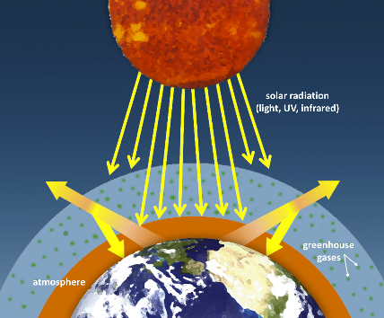**Solar radiation hits the earth. Some is absorbed and heats the earth. Some is reflected and returns to space. Some is reflected and hits molecules of greenhouse gases in the atmosphere causing them to vibrate and scatter the energy. Some of the scattered energy returns to earth, trapping the energy and further heating the earth.**

Draw two energy chart diagrams: for a) the lemonade and b) the ice cube if a single ice cube is added to room temperature lemonade and completely melts significantly cooling the lemonade.

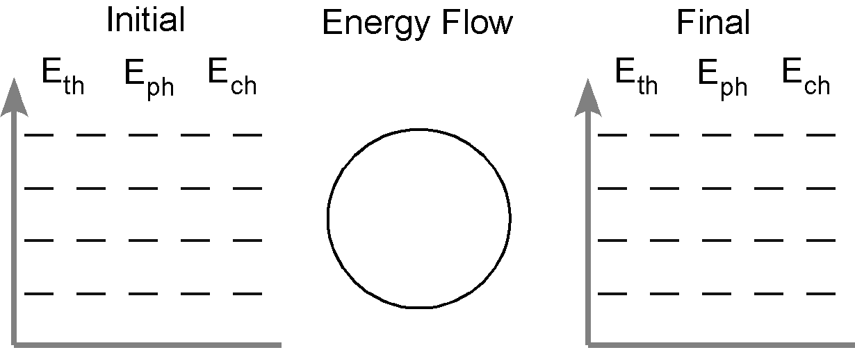

Lemon

-ade



Ice

cube

1. If 16.3 L of argon gas at a pressure of 3.2 atm is changed to 1.8 atm at constant temperature, what is the new volume? *Draw particle diagrams to support your answer.*

|  |  |  |  |
| --- | --- | --- | --- |
|  | **P** | **T** | **V** |
| **Initial** | **3.2 atm** | **C** | **16.3 L** |
| **Final** | **1.8 atm** | **C** | **???** |
| **Effect** |  | **C** |  |

**V2 = 29.0 L**

1. A gas with a volume of 4.0 L at a STP is allowed to expand to a volume of 12.0 L and 22.9C. What is the new pressure in the container? *Draw particle diagrams to support your answer.*

|  |  |  |  |
| --- | --- | --- | --- |
|  | **P** | **T** | **V** |
| **Initial** | **1 atm** | **273 K** | **4.0 L** |
| **Final** | **???** | **296 K** | **12.0 L** |
| **Effect** | **or** |  |  |

**P2 = 0.361 atm**